Name : L.Harshith

Roll.No : 2403A51058

Batch : 02

LAB TEST – 01

1. (2 Marks) Write a Python program to extract all URLs (web links) from a block of text using regular expressions. Use the Cursor AI tool with zero-shot prompting to generate the solution

Prompt :

Write a Python program to extract all URLs (web links) from a block of text using regular expressions.the code should define a function that takes a string as input and returns a list of urls found.

Code :

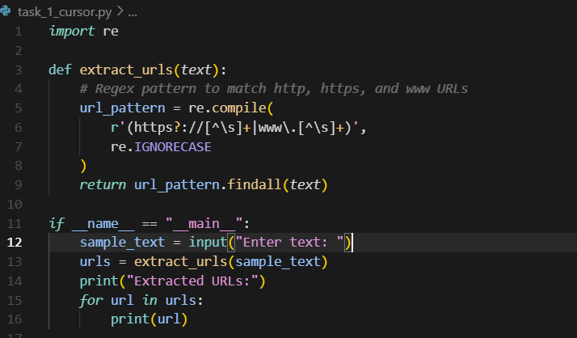

Output :

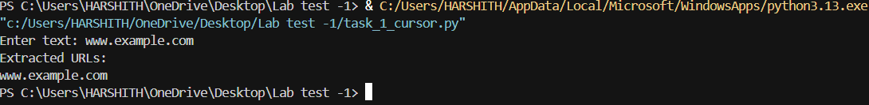

2.(2 Marks) Given a list of books with their genres, write a Python function that recommends books based on a user’s preferred genre. Use the Cursor AI tool. Use few shot prompting.

Prompt :

Given a list of books with their genres, write a Python function that recommends books based on a user’s preferred genre.for example if the input is maths then it should recommends books based on that subject like rd sharma etc. if the input is physics then it should recommends books based on that subject like physics wallah.

Code :

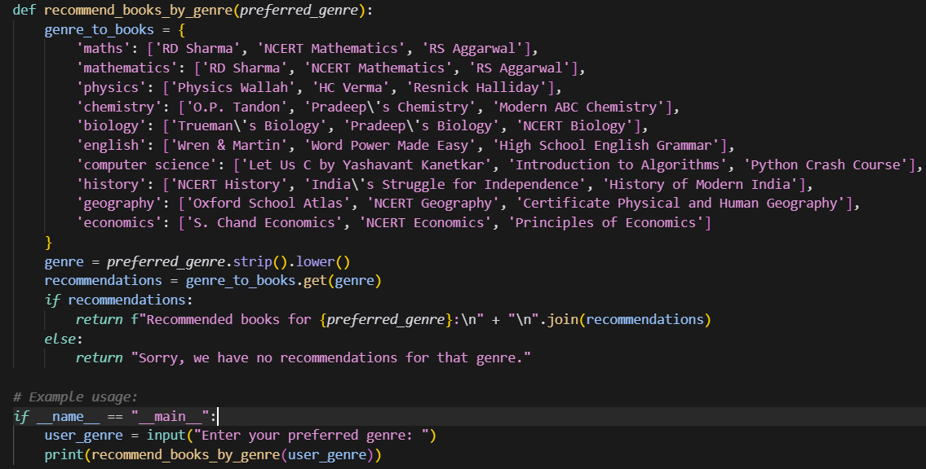

Output :

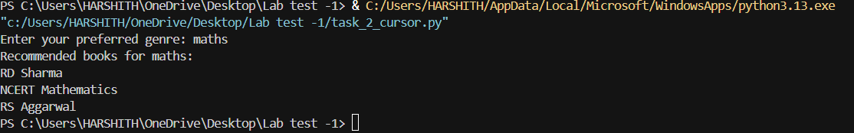

3)(2 Marks) Write a Python program that generates all prime numbers between start and end (both inclusive) entered by the user. Use GitHub Copilot along with VS Code. Use few shot prompting.

Prompt :

Write a Python program that generates all prime numbers between start and end (both inclusive) entered by the user. Read the input from the console.For example if the input is 2 and 10 then the output should be in the format of Prime numbers between 2 and 10 : 2 3 5 7 .

Code :

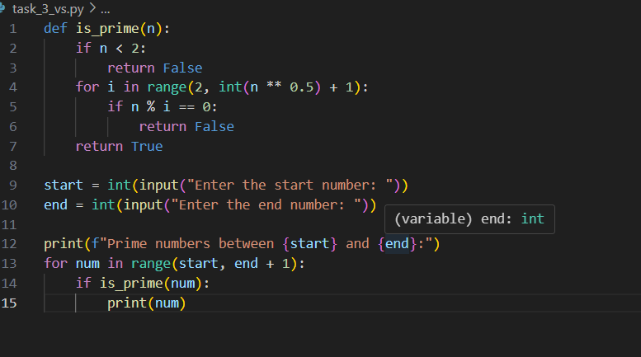

Output :

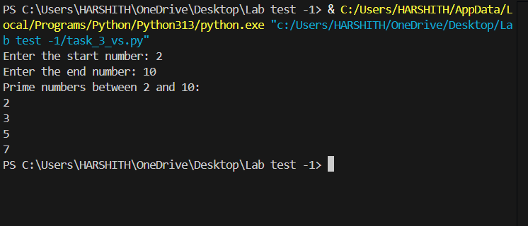

4) (2 Marks) Write Python code that takes a list of student names and generates institutional email IDs in the format: <firstletter><lastname>@sru.edu.in Example: "Anita Sharma"→ asharma@sru.edu.in. Use GitHub Copilot along with VS Code. Use few shot prompting.

Prompt :

Write Python code that takes a list of student names and generates institutional email IDs in the format: <firstletter><lastname>@sru.edu.in Example: "Anita Sharma"→ [asharma@sru.edu.in](vscode-file://vscode-app/c:/Users/HARSHITH/AppData/Local/Programs/Microsoft%20VS%20Code/resources/app/out/vs/code/electron-browser/workbench/workbench.html). read the input from the console.

Code :

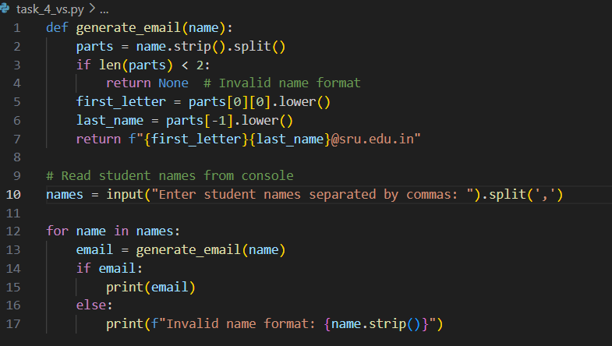

Output :

